

**DUYTAN UNIVERSITY**

**INTERNATIONAL SCHOOL**

**--------------🙖🙐✰🙖🙐-------------**



**CMU-SE 100**

**INTRODUCTION TO SOFTWARE ENGINEERING**

**SYNTHESIS REPORT GROUP PROJECT**

**Mentor: Msc. Huy Nguyen Dang Quang**

***Team Member*:**

**Nguyet, Le Thi Thanh**

**Thanh, Dang Thi Phuong**

**Phuc, Le Van**

**Loc, Nguyen Van**

**Group Project - Mentor:**

Name Signature Date

Da nang, 12/2023

**PROJECT INFORMATION**

| **Project Acronym** | FMS |
| --- | --- |
| **Project Title** |  | | | |
| **Start Date** | 12/03/2023 | **End Date** | 12/25/2023 | |
| **Lead Institution** | International School, Duy Tan University | | | |
| **Team Member** | **Name** | **Email** | | **Phone** |
|  | Le Thi Thanh Nguyet | thanhnguyet2203@gmail.com | | 0934825397 |
|  | Dang Thi Phuong Thanh | dangthiphuongthanh.07072005@gmail.com | | 0795514282 |
|  | Nguyen Van Loc | vanloc13051509@gmail.com | | 0356623211 |
|  | Le Van Phuc | vanphuc070505@gmail.com | | 0375001026 |
|  |  |  | |  |

**DOCUMENT NAME**

| **Document Title** | **Synthesis Report Group Project Document** | | |
| --- | --- | --- | --- |
| **Reporting Period** | 25 – Dec – 2023 | | |
| **Author(s)** | Le Thi Thanh Nguyet  Dang Thi Phuong Thanh  Le Van Phuc  Nguyen Van Loc | | |
| **Role** | Team Leader  Team Member  Team Member  Team Member | | |
| **Date** |  | **Filename** | Team 5 - Group project CMU SE 100.docx |

**SIGNATURE**

***Document Approvals:*** *The following signatures are required for approval of this document.*

| **Mentor** | Huy, Nguyen Dang Quang | **Signature:** |  |
| --- | --- | --- | --- |
| **Date:** |  |
| **Team Lead** | Nguyet, Le Thi Thanh | **Signature:** |  |
| **Date:** |  |
| **Team member(s)** | Thanh, Dang Thi Phuong | **Signature:** |  |
| **Date:** |  |
| Phuc, Le Van | **Signature:** |  |
| **Date:** |  |
| Loc, Nguyen Van | **Signature:** |  |
| **Date:** |  |
|  | **Signature:** |  |
| **Date:** |  |
|  | **Signature:** |  |
| **Date:** |  |

**REVISION HISTORY**

| **Version** | **Date** | **Description** |
| --- | --- | --- |
| **1.0** |  | **Make Synthesis Report Group Project Document** |
| **2.0** |  |  |
| **3.0** |  |  |

**TABLE OF CONTENTS**

**1. INTRODUCTION**

- Zone six.

- Address: 40 Tran Van Du, Bac Mi An, Ngu Hanh Son, Da Nang City

-Phone: 093 334 44 13

-Field: cafe and snacks

**2. DESCRIBE BUSINESS PROCESSES OF RESTAURANT**

The main business processes in the operation of the café include:

1. Employee management: Employees are the face of the shop, who take care of customers in the best way and convey business messages to customers. There should be a detailed job description for employees such as: service culture, operating process, work to do, working time.

2. Source management: Source management is very important in the coffee shop business, so you need to plan in detail such as choosing partners, reputable product suppliers, long-term quality, reasonable prices, time, delivery location periodically.

3. Product storage warehouse: It is necessary to statistics the quantity of goods entered, then update to sales management software.

4. Management and control of revenue and expenditure: The daily expenses of the shop need to be clearly declared and approved by the manager. The revenues of the shop: need to be clearly statistics and checked at each shift or at the end of the day.

5. Professional restaurant service process: In order for the café to operate smoothly and logically, it is necessary to have a management process that does not lead to chaos and unprofessionalism.

6. Manage the drink/food menu at the café: This involves updating new drinks and implementing marketing for the café.

**3. LIST OF PARTICIPANTS TO REQUIREMENTS GATHERING**

-Customers

-Staff

-Cashiers

-Manager

**4. THE TECHNICALS USING TO REQUIREMENTS GATHERING**

1/Observation:

_For customers: Observe customers when they come to the restaurant to understand their needs.

_For staff: Observe how staff welcome customers to understand the staff’s working process.

_For cashiers: Observe the payment process to understand the payment procedures for customers.

-Observation helps us quickly recognize the nature of the problem.

2/Interview:

_For customers: Interview customers about their experience at the restaurant regarding food, service attitude, and hygiene.

_For staff: Interview staff about the steps from when a customer starts entering the restaurant, to ordering, and to leaving. Using the interview method will provide an overview of the restaurant’s internal operations.

Interviewing creates an exchange space, making it easier and faster to understand.

_For the cashier: Interview the customer’s payment steps.

3/Questionnaire:

_Create a questionnaire: Ask questions related to the restaurant’s service, the restaurant’s operation. Using the questionnaire helps the questions to be coherent, not verbose and repetitive.

**4/Direct exchange based on a similar model or website:**

_Create a web page: Includes reviews, feedback from customers and the restaurant. Using this method makes it more flexible between customers and staff, creates credibility for customers, and can share quickly and for many people.

**5. ASSIGNMENT TEAM MEMBER TO REQUIREMENTS GATHERING**

| Nguyet, Le Thi Thanh | Staff | -When the customer is done, what do you do?  -How long does it take to make the dish?  -What to do next after you're done? |
| --- | --- | --- |
| Thanh, Dang Thi Phuong | Cashier | -When the order is done, what should be done? |
| Phuc, Le Van | Customers | -When I enter the shop, what will I do?  -What should I do after ordering water?  -After payment, what should I do next?  -How is the quality of service and food? |
| Loc, Nguyen Van | Manager | -How to manage the store?  -Do you want to change anything? |

**6. INTRODUCTION PROJECT**

**6.1. Project Objectives**

Software that helps manage business operations such as billing, invoicing, statistics, employee management, payroll, etc. Cafe sales management software helps users save time, work quickly, and easily manage and operate their business.

Building a new system that is suitable, easy to understand, and easy to use for software users. To understand the sales management system, it is necessary to manage which areas to build applications that meet practical needs.

Help optimize the system management of the cafe, making management work easier and more convenient. Help yourself become more creative and think through interactive interface design with users, applying your own knowledge to practice.

**6.2. Project Scope**

The scope revolves around sales operations, following the management operations of

a coffee shop, fully ensuring the main functions of the software and exploiting the

New functions related to coffee shop management are intended to further enhance the software utility section.

**6.3 Identify the Functional Requirement & Non-Functional Requirement**

## **a) High level Functional Requirement (FR)**

| **FR1.1** | Title | **View menu** |
| --- | --- | --- |
| Cashier  Client  Staff | - The person who carries out transactions and payment activities when customers come to shop or use services at the store.  - Organizations or individuals wishing to purchase goods  - clean up, make water |
| Description | See menu, prices |
| **R1.2** | Title | **Choosing Food & Drinks** |
| Client  Staff | - Organizations or individuals wishing to purchase goods.  - clean up, make water |
| Description | Customers choose items from the menu and choose quantity. Staff takes notes if customers have other requests. |
| **FR1.3** | Title | **View invoice** |
| Cashier  Client  Staff | - The person who carries out transactions and payment activities when customers come to shop or use services at the store.  - Organizations or individuals wishing to purchase goods.  - Clean up, make water |
| Description | -Customers view invoices, view promotions, and make payments |
| **FR1.4** | Title | **Select payment method** |
| Cashier  Client  Staff | - The person who carries out transactions and payment activities when customers come to shop or use services at the store.  - Organizations or individuals wishing to purchase goods.  - Clean up, make water |
| Description | -Pay in cash or by credit card. |
| **FR1.5** | Title | **Notification of receiving food/water** |
| Cashier Client | - The person who carries out transactions and payment activities when customers come to shop or use services at the store.  - Organizations or individuals wishing to purchase goods. |
| Description | When the dish is completed, the staff will notify the customer |
| **FR1.6** | Title | **Pay, print invoices** |
| Cashier Client  Staff | - The person who carries out transactions and payment activities when customers come to shop or use services at the store.  - Organizations or individuals wishing to purchase goods.  -Clean up, make water |
| Description | -Compile list of dishes, make payment and issue invoice. |
| **FR1.7** | Title | **Sales report** |
| Manager | -A manager is someone who plans, organizes, leads and controls the work of others |
| Description | -Store management and staff supervision. |

**b) List of Non-Functional Requirement**

1. Performance: The website needs to be fast and respond immediately to user requests. It also needs to be able to handle a large number of transactions simultaneously.
2. Reliability: Websites need to operate reliably, with minimal downtime and as few errors as possible.
3. Security: Customer data and payment information need to be protected from attacks and information leaks. Websites also need to comply with data security regulations
4. Scalability: The website needs to be scalable to meet the increasing demands of users and transactions.
5. Ease of use: The user interface needs to be friendly and easy to use, even for those who have no experience with technology.
6. Integration: The website should be easy to integrate with other systems such as online payment or delivery systems.
7. Compatibility: The website needs to operate efficiently on all popular web browsers and must be optimized for both desktop and mobile devices..
8. Maintenance and support: The website needs to be easy to maintain and upgrade. In addition, technical support needs to be available to resolve any issues that users encounter.

**7. THE USER REQUIREMENT ANALYSIS**

**7.1 Business Function Diagram**

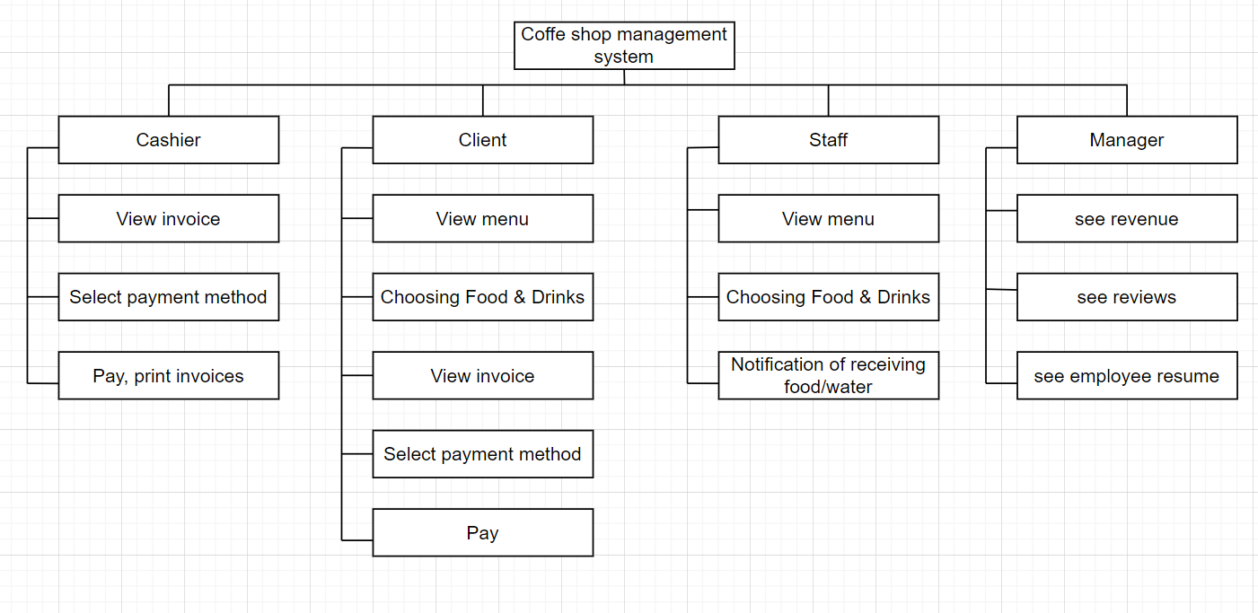

**7.2 Context Model**

**a) Context Model**

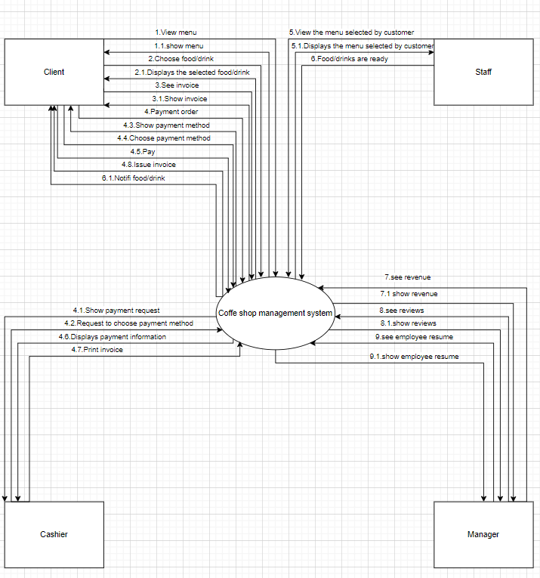

**b) System Context Description**

System description: for customers to easily use the service of ordering water, paying, printing invoices, saving information. Manage and track shop sales. Confidentiality and safety, calculation, updating of information.

**7.3 List of Actor**

-Cashier: The person who carries out transactions and payment activities when customers come to shop or use services at the store.

-Client: Organizations or individuals wishing to purchase goods.

-Staff: Clean up, make water

-Manager:-A manager is someone who plans, organizes, leads and controls the work of others.

**7.4. List of Use Cases**

| **Use case ID** | **Use case name** | **Functional Req.** |
| --- | --- | --- |
| ***UC.01*** | **View menu** | ***FR1.1*** |
| ***UC.02*** | **Choosing Food & Drinks** | ***FR1.2*** |
| ***UC.03*** | **View invoice** | ***FR1.3*** |
| ***UC.04*** | **Select payment method** | ***FR1.4*** |
| ***UC.05*** | **Notification of receiving food/water** | ***FR1.5*** |
| ***UC.06*** | **Pay, print invoices** | ***FR1.6*** |
| ***UC.07*** | **Sales report** | ***FR1.7*** |

**8. PROJECT PLAN**

| **No.** | **Task Name** | **Duration (Days)** | **Start** | **Finish** | **Assign to** |
| --- | --- | --- | --- | --- | --- |
| **1** | **Initial** | **7** | **20/08/2022** | **26/08/2022** | **Nhan, Tuan, Huy, Huy** |
| 1.1 | Project Kick-off Meeting | 1 day | 20/08/2022 | 20/08/2022 | Nhan,Tuan,Huy,Huy |
| 1.2 | Discuss about project ideal | 1 day | 21/08/2022 | 21/08/2022 | Nhan,Tuan,Huy,Huy |
| 1.3 | Create Proposal Document | 1 day | 22/08/2022 | 22/08/2022 | Nhan,Tuan,Huy,Huy |
|  |  |  |  |  |  |

**9. TECHNICAL CONSTRAINTS**

### **9.1 Technical to develop:**

* ***Languages****: Python, Nodejs, React Native, Reactjs*

### **9.2 Environment:**

* ***Web browsers****: Google Chrome, Molliza Firefox, Apple Safari, Cốc Cốc, Microsoft Edge.*
* ***Environment:*** *Microsoft windows, Mac Os, Android, iOS,..*

### **9.3 Another:**

* ***Management tool****: Trello, Slack*
* ***Design tool****: Figma*
* ***Manage Source code tool****: Git,Github*
* ***Test tool*** *: Katalon Studio*

**10. ANALYSIS & MODELING REQUIREMENT**

**10.1. Use Case Diagram**

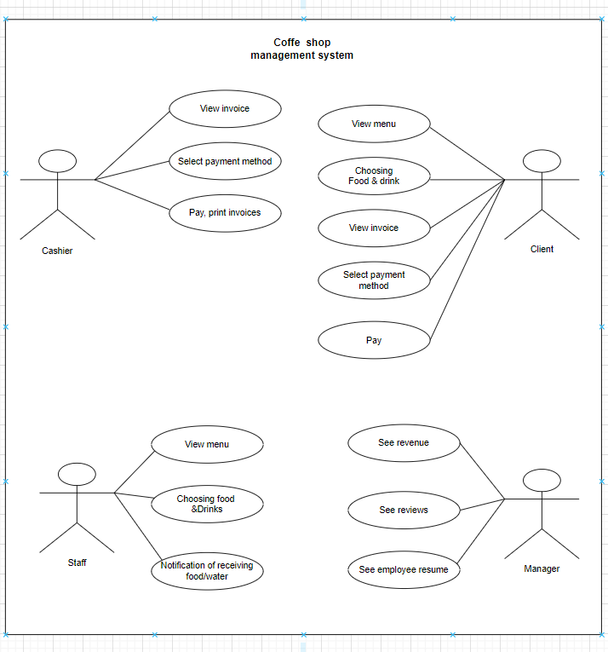

## **10.2. List of Business Rule**

| Code | Business rules | Use case |
| --- | --- | --- |
| *BR1* | *Customers order their own water at the counter* | *UC.02* |

**10.3. Activity Diagram**

**a) The steps performed of function abc….**

The steps performed of function : View menu

| **Client** | **System** |
| --- | --- |
| 1. Click on the menu | 1. Show menu |
| 1. Check menu   3.1.if it run out: Announcing the end of food/drinks  3.2.If there is food/drink left | 1. Displays remaining food/drinks |
| 1. See menu | 1. Show close menu button |
| 1. Close menu |  |

The steps performed of function : Pay

| **Client** | **System** |
| --- | --- |
| 1. Select payment | 2.Displays the amount to be aid |
| 4.Select anh payment method | 3. Shows the payment method |
| 6.Pay | 5. Check payment conditions  5.1.if false: Notify customers of unsuccessful payment  5.2.if true: displays the amount payable entry |
|  | 7.Payment success |
|  |  |

The steps performed of function: CHOOSING FOOD&DRINK

| **Client** | **System** |
| --- | --- |
| 1.Find food/drink | 2.show all food/drink |
| 3.select food/drink | 4.check if there is food/drink left  4.1.if false:notify that food/drink is out of stock  4.2.if true: displays the quantity selection item |
| 5.choose quantity | 6.show order item |
| 7.choose to order | 8.notification of successful order |

The steps performed of function: VIEW INVOICE

| **Cashier** | **System** |
| --- | --- |
| 1.View invoice | 2.Show invoice |
| 3.Close invoice | 4.Shows closed successfully |

The steps performed of function: SEE REVENUE

| **Cashier** | **System** |
| --- | --- |
| 1.See revenue | 2.Show revenue |
| 3.Close revenue | 4.Shows closed successfully |

**b) Activity Diagram of function abc….**

-Activity Diagram of function VIEW MENU:

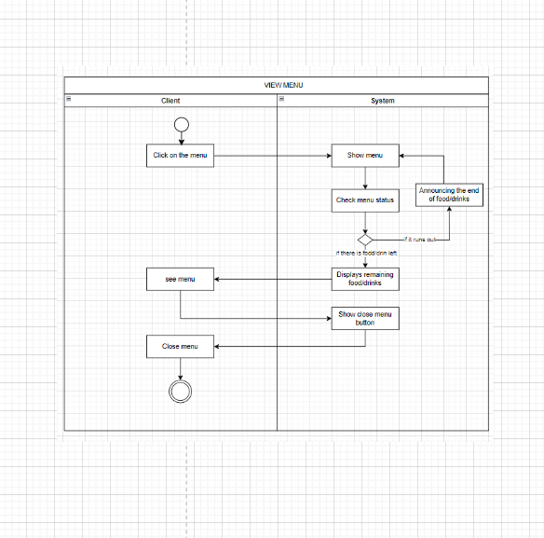

Activity Diagram of function: PAY

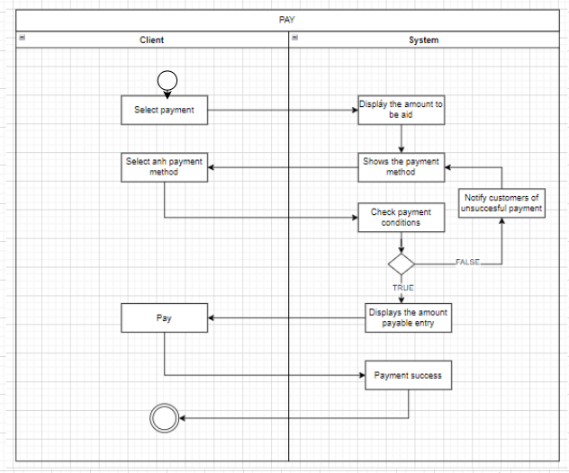

Activity Diagram of function: CHOOSING FOOD & DRINK

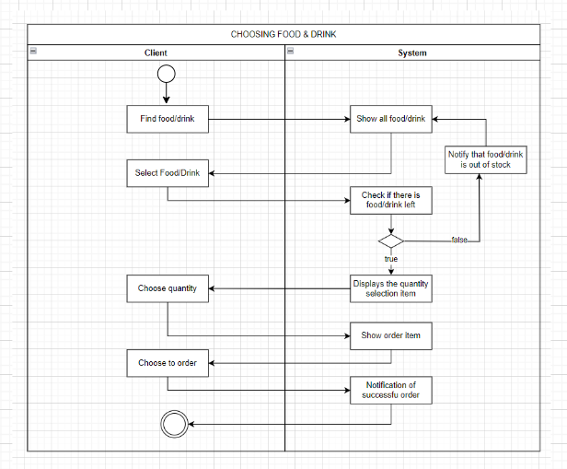

Activity Diagram of function: VIEW INVOICE

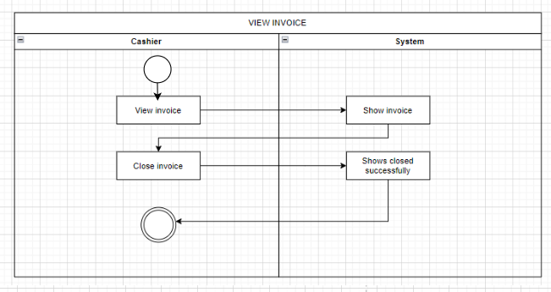

Activity Diagram of function: SEE REVENUE

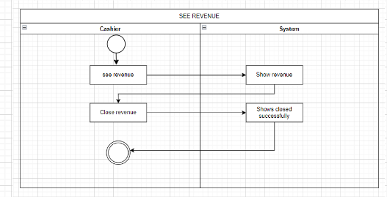

**11. INTERFACE DESIGN**

**<** Thiết kế giao diện hệ thống ứng dụng **>**



**11.1. Introduction tool design**

Canva: is an online design platform with a friendly and easy-to-use interface. Designed to help users create professional graphic designs without the need for advanced design skills. Canva offers a wide range of tools, from ready-made templates for graphic design, to image editing tools, layout creation, and even video design. Canva's drag and drop feature makes it easy for users to create designs for a variety of purposes, including designs for social media, posters, banners, invitations, and more. With Canva, users can carry out design projects quickly and effectively without having to have in-depth knowledge of graphics.

**11.2 User Interface Design for ABC Function**

<Thiết kế giao diện hệ thống cho các chức năng phần mềm>

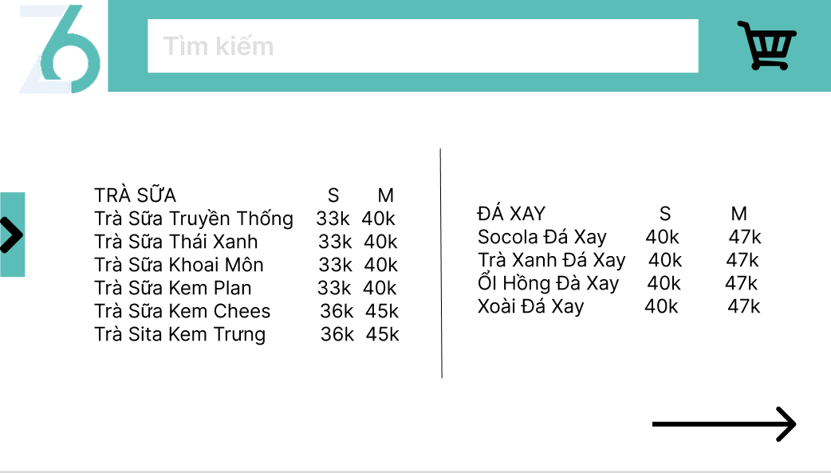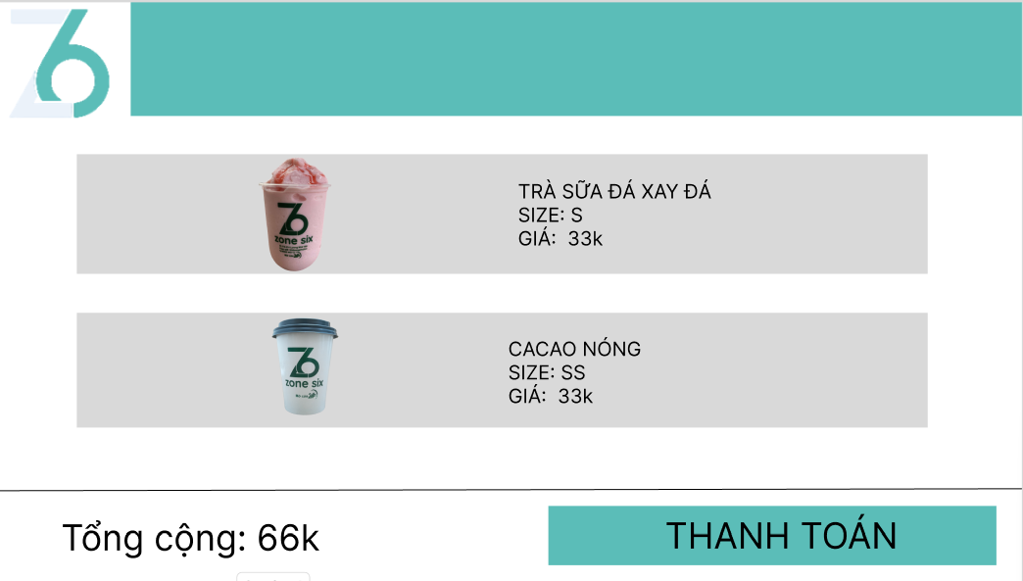

**12. CONFIGURATION MANAGEMENT**

**a) Introduction the tool Source Code Management**

GitHub is a web-based source code repository service for software development projects. This service provides the ability to manage source code and its versions according to the Git mechanism and has added some of its own features. Some key features of GitHub include:

**b) Introduction Key Functional**

* Souce code management: GitHub helps developers manage, inspect source code, and organize it in a distributed data format.
* Project management: GitHub operates like a social network for developers, making their exchanges and interactions more convenient.
* Community support: GitHub has made a significant impact in the open-source community.

**c) The Screen Shot apply Source Code Management of team**

<Giao diện quản lý mã nguồn/tài liệu của nhóm>

**13. TESTING**

**a) Introduction to method testing apply of this project**

*<Giới thiệu phương pháp kiểm thử được áp dụng cho dự án>*

**b) Test Cases**

*<Thiết kế test case cho các chức năng (05 chức năng bất kỳ), theo mẫu Test Case đính kèm>*

**14. CONTRIBUTION**

*<Team member contributed significantly to team's success (%)>*

| **No.** | **Participant**  *<Họ tên>* | **Role**  *<Vai trò>* | **Responsibilities**  *<Trách nhiệm cụ thể được phân công, đóng góp cho bài tập nhóm>* | **%**  *Mức độ (%) đóng góp cho bài tập nhóm* |
| --- | --- | --- | --- | --- |
| **1** | **Le Thi Thanh Nguyet** | **leader** |  |  |
| **2** | **Dang Thi Phuong Thanh** | **Team member** |  |  |
| **3** | **Le Văn Phuc** | **Team member** |  |  |
| **4** | **Nguyen Van Loc** | **Team member** |  |  |